Stroop Effect
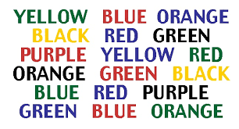

Stroop Effect
In order to demonstrate the concept of Proactive Interference, one can use the Stroop Effect. The typical Stroop Effect can be demonstrated by first presenting colors in written in the word of each respective color. This is the control condition. In the experimental condition, participants are presented with the same colors but now written in another color. For example, the word yellow might be written in red. In each of the conditions the participant is the read the words as quickly as possible correcting any mistakes as they go along. Students can work in groups of 2 and their partner can time them in each condition.

Animal Stroop Effect
For a variation of the traditional Stroop Effect which many students may have already seen, the animal Stroop Effect also works quite well. In the control condition, the participant is presented with shapes of animals, within the shape it contains the correct name of the animal. In the experimental condition, the name contained in the shape of the animal is different from the shape. For example, the word pig might be written in the shape of a bear. Students should work with a partner and time each other on each condition.

Connection to Proactive Interference
The connection to Proactive Interference, is that prior learning inhibits the experimental task in both variations of the activity. If the person did not know how to read, the experimental condition would not be slower than the control condition, but in most cases, it takes about twice as long to complete the experimental as it does to complete the control condition because the expectation of colors or animals to be consistent in shape and words has been violated, our prior experiences are inhibiting our ability to complete the task at hand.

