Open Your Class with This Tomorrow- Hidden Valley Road
Examining the Interaction of Nature and Nurture related to Schizophrenia

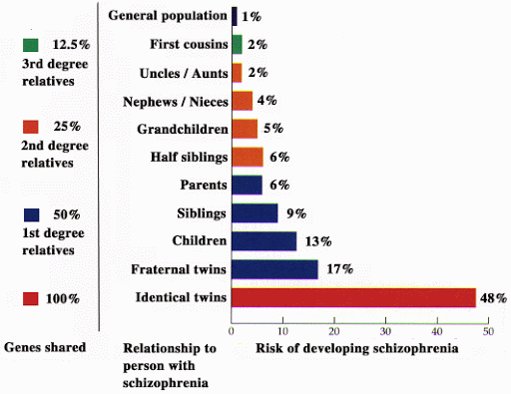

Source: http://www.schizophrenia.com/research/hereditygen.htm

- Define heritability and, in a single sentence, apply the term to the information presented in the graph above.

- Look at the risk of developing schizophrenia in identical twins. What does this tell us about the heritability of the illness? Also, relate this to the risk factors for other family members.

- List at least three environmental factors that may cause identical twins raised together to have higher rates of schizophrenia than those raised apart.

- Provide a specific example of how genes and environmental factors intermingle to contribute to the development of schizophrenia.

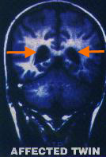
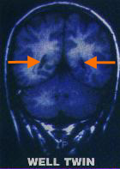

- What type of brain scan is depicted above? What does this demonstrate about the differences in the brains of identical twins? Note that the image of the twin on the left has schizophrenia, and the one on the right does not.

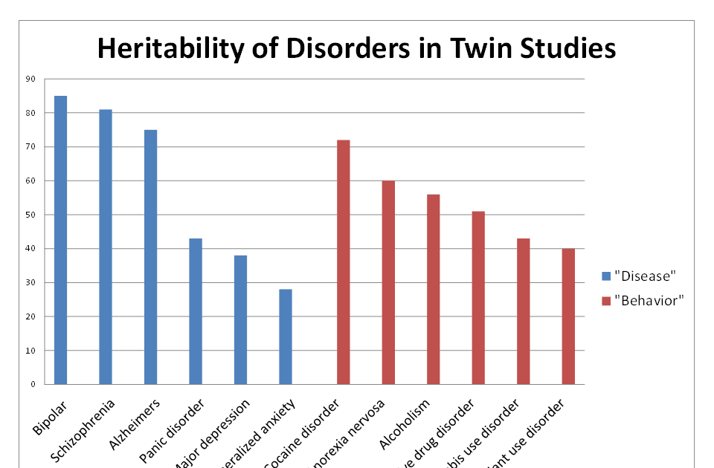
Source: http://brainposts.blogspot.com/2010/12/mental-disorders-diseases-or-behavioral.html

- Examine the information in the graph above. How does schizophrenia compare to other “diseases” regarding heritability? How does it relate to other “behaviors”?

