Scanning the Brain
https://www.youtube.com/watch?v=l9swbAtRRbg
CT scans
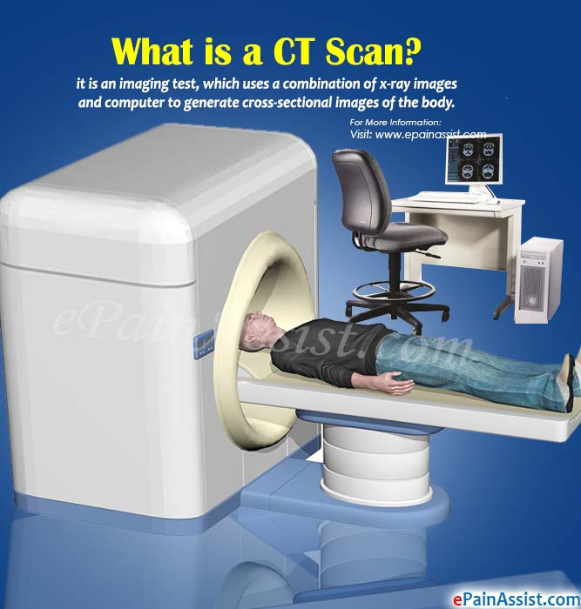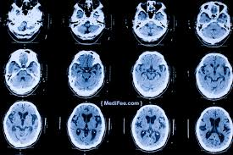

- How does a CT scan work?

- Is a CT scan used to detect issues with structure or function of the brain?

- Give an example of when a person might have a CT scan.

- What is a drawback to using a CT scan?

MRI

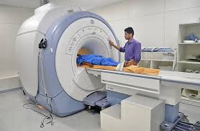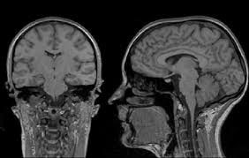

- How does an MRI differ from how a CT scan works?

- Is an MRI scan useful for detecting issues structures or function or the brain?

- Give an example of when an individual might have an MRI scan

- What is a drawback of having an MRI scan?

PET scan
https://www.youtube.com/watch?v=yrTy03O0gWw
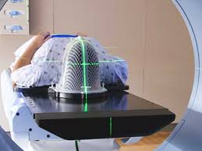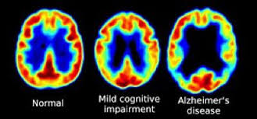

- How does a PET scan work?

- Is a PET scan useful for detecting issues with structures or function of the brain?

- Give an example of when an individual might have a PET scan

- What is a drawback of having a PET scan?

fMRI scan
https://www.youtube.com/watch?v=nvB9hAarzw4

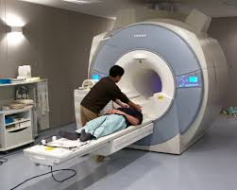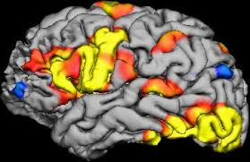
- How does a fMRI scan work?

- Is a fMRI scan useful for detecting issues with structures or function of the brain?

- Give an example of when an individual might have a fMRI scan

- What is a drawback of having a fMRI scan?

EEG
https://www.youtube.com/watch?v=KXS268XsRic
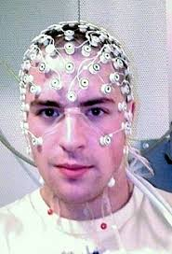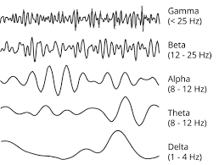

- How does an EEG scan work?

- Is an EEG scan useful for detecting issues with structures or function of the brain?

- Give an example of when an individual might have an EEG scan

- What is a drawback of having an EEG scan?

