AP Psychology
Brandt

Will the Real Elmo Monster Please stand up? Looking for colorful sesame street characters in your peripheral vision.

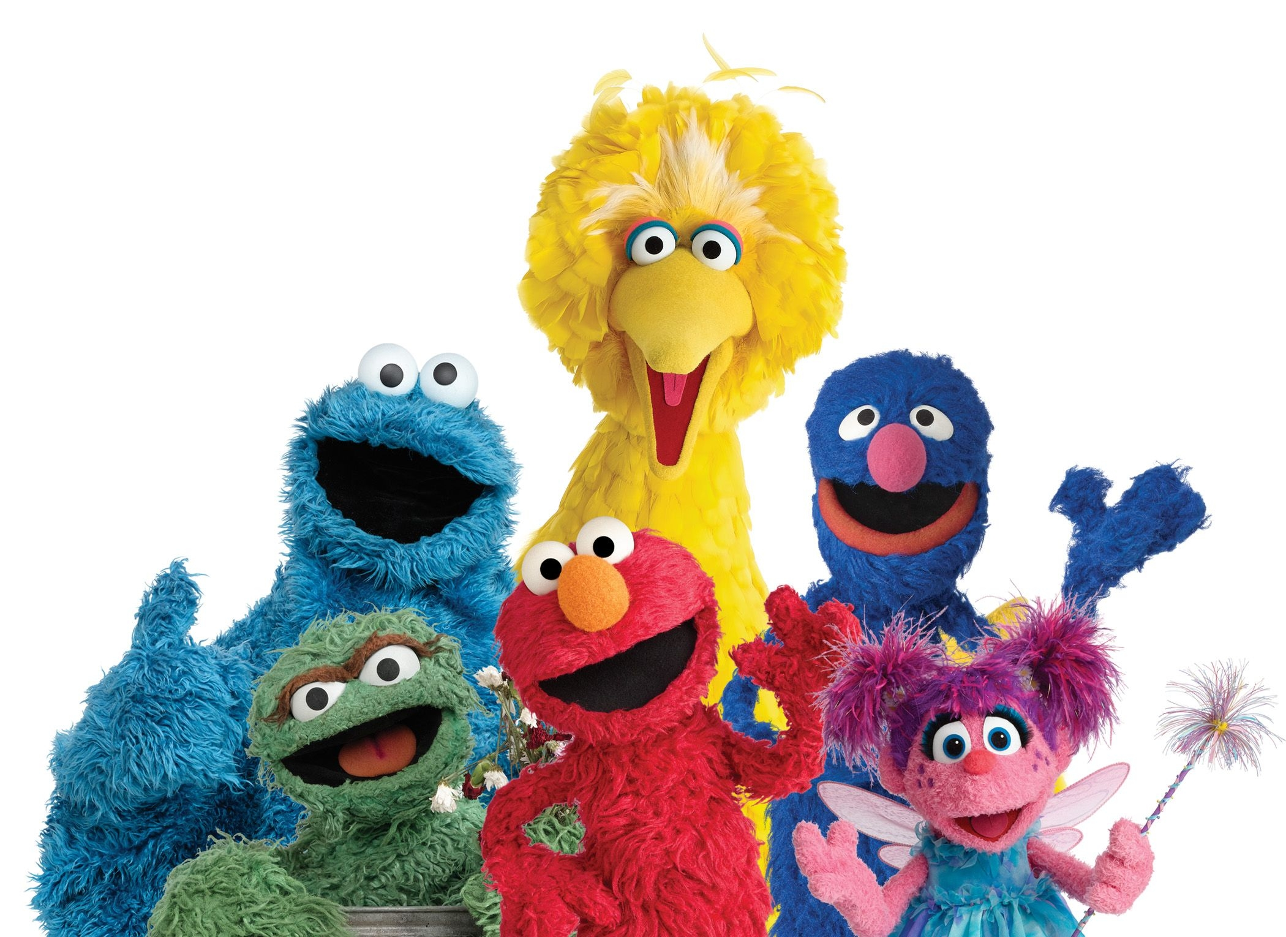

Procedure:
Print out each of the Sesame Street characters and their “imposter” counterparts. Also, print out the sheet with the giant X, which will serve as the focal point for the presentations.

Tape the sheet with the X on the board. Measure roughly 5 feet on either side of the X, and make a mark on the board, be sure that these are equally spaced from the X. These are the marks where the volunteers will stand when holding up their characters.

Ask for a volunteer from class who will focus on the Large X in the center of the board. They are not to move their gaze from the X (for another option, each round can be completed by a different student). Other students will stand in front of the marks on the board and hold up a photo of either the actual character (Big Bird) or the imposter character (imposter Big Bird). The student participant will try to select the real character. This process will repeat for each respective character.

Explanation: The fovea is the area of highest visual acuity in the retina. The fovea holds only cones used for color vision. When focusing on the X in the center of the board, one is using their cones. The characters to the left and right of the X should appear in the participant’s peripheral vision. The rods are located primarily in the peripheral vision and responds to dim light. The colorful images of the characters should be difficult to detect in the peripheral vision, likely making the selection of the real characters little better than chance.

Inspired by the series Brain Games on National Geographic.

