Little Things are Big
Reflection Questions

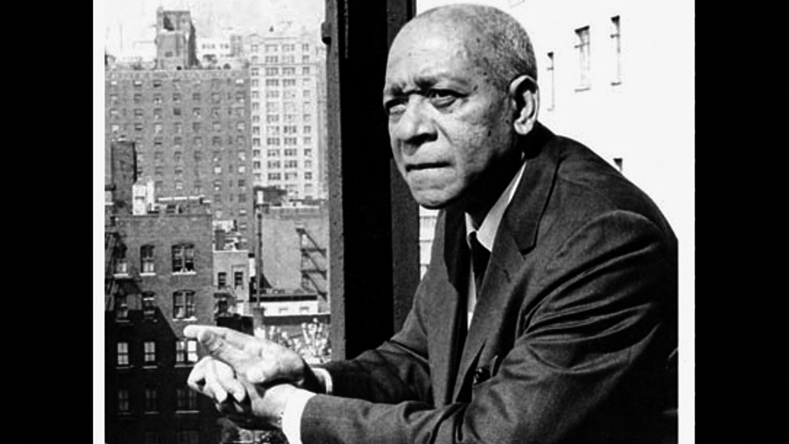
- What was Jesús Colón’s dilemma on the train? What were the different factors he was weighing in his mind?

- What was at stake in Colón’s decision? How did he feel about his choice afterward?

- Why do you think he wrote this story? Why do you think Colón titled his essay “Little Things Are Big”?

- Create a different ending to the story. What do you think Colón might have done? How do you think the woman might have responded to the action you have imagined for Colón? Describe the effect of that action on Colón.

- How do your concerns about how others might perceive you affect your actions?

